Comment on the "Thermodynamic Dissociation Constant of the Bisulphate Ion from Raman and Ion Interaction Modelling Studies of Aqueous Sulphuric Acid at Low Temperature" by D. A. Knopf, B. P. Luo, U. K. Krieger, and Thomas Koop (J. Phys. Chem. A 2003, 107, 4322-4332)

Simon L. Clegg* and Peter Brimblecombe
School of Environmental Sciences, University of East Anglia, Norwich NR4 7TJ

Knopf et al.¹ have recently determined the degrees of dissociation of the bisulphate ion (α_{HSO4}) in aqueous sulphuric acid to low temperature. The results, together with similar measurements of Myrhe et al.,² are a valuable addition to the available data for the acid and will enable more reliable models of aqueous mixtures containing sulphuric acid to be developed.
The authors use an ion-interaction model, in which individual species molalities and activity coefficients are calculated, to estimate the value of the thermodynamic dissociation constant (K_{II}) for bisulphate dissociation as a function of temperature. In their Figures 8 and 9 Knopf et al. compare K_{II} with values from the equation of Dickson et al.³ which was used in the Aerosol Inorganics Models (AIM) of Clegg and co-workers for the systems H₂SO₄-H₂O,⁴ H⁺-HSO₄⁻-SO₄²⁻-NO₃⁻-Cl⁻-Br⁻-H₂O,⁵⁻⁷ and H⁺-NH₄⁺-HSO₄⁻-SO₄²⁻-NO₃⁻-H₂O.^{5,6} Knopf et al. go on to compare their own model with AIM for H₂SO₄-H₂O⁴ (not cited by Knopf et al.) in terms of bisulphate dissociation, single ion activity coefficients, activity coefficient products, and water activities (their Figures 6, 7, 10 and 11). Very large differences are found at low temperatures, implying that AIM is inaccurate for aqueous H₂SO₄ and its mixtures with other electrolytes. If true, this would have important implications for calculations of gas solubilities and phase equilibria in tropospheric and stratospheric acid sulphate aerosols, for which the AIM models are used extensively.
Here we compare AIM and the model of Knopf et al., on the correct basis, with the best available data for water and H₂SO₄ activities. We show that the AIM model appears to yield more accurate predictions of water and H₂SO₄ activities under most conditions, including low temperatures. We determine the reasons for this and offer some general comments on the limitations of the models.

1. HSO₄⁻ Dissociation and Thermodynamic Properties
While it is generally desirable that solution models represent the observed speciation in solution (in this case the equilibrium HSO₄⁻ = H⁺ + SO₄²⁻), it is not a necessary condition for the accurate representation of solute and solvent activities. When developing the AIM H₂SO₄-H₂O model Clegg and Brimblecombe⁴ included the degree of dissociation data that were available at the time (at 273.15 K, 298.15 K, and 323.15 K - see their Table 15), but otherwise allowed the calculated HSO₄⁻/SO₄²⁻ speciation to vary freely in order to most accurately represent the available activity and thermal data. Consequently, while the calculated degrees of dissociation, and mSO₄²⁻/mHSO₄⁻ ratios, predicted by the AIM model differ from the measurements and model of Knopf et al. at high molality (their Figures 6 and 7) this does not reflect the relative accuracies of the models in the prediction of water and H₂SO₄ activities. Furthermore our own tests, discussed in the section below, suggest that the close fit of the Knopf et al. model to their degree of dissociation data was obtained at the expense of an accurate representation of H₂SO₄ and H₂O activities.
We have a further comment regarding Figures 6 and 7 of Knopf et al. At molalities below about 4 mol kg⁻¹ their experimental results and α_{HSO4} calculated using AIM agree quite well at all T, apart from a roughly constant offset of about 0.075 to 0.1. Comparisons at 298.15 K both with the recent experiments of Myrhe et al.,² and with five earlier studies (not cited by Knopf et al., see Table 15 of Clegg and Brimblecombe⁴), suggest that both experimental and fitted α_{HSO4} of Knopf et al. are high by about 0.1.
The AIM H₂SO₄-H₂O model uses the equation of Dickson et al.³ for K_{II}, which is based upon data covering the temperature range 283.15 K to 523 K. Knopf et al. show that this expression, when extrapolated to 0 K, does not obey the Nernst Heat Theorem. However, the Dickson et al.³ equation only differs significantly from their own below about 225 K. In order to determine whether this has an effect on the prediction of water and H₂SO₄ activities these quantities must be compared directly with available thermodynamic data. We do this in section 3, at the same time correcting errors made by Knopf et al. in their Figures 10 and 11.

2. Thermodynamic Models of H₂SO₄-H₂O
The model developed by Knopf et al. to estimate K_{II} from their experimental data is based upon the ion-interaction equations of Pitzer,⁸ including a one parameter extension originally proposed by Archer.⁹ It is essentially the same as that used by Clegg, Rard and Pitzer¹⁰ in their critical review of the thermodynamic properties aqueous H₂SO₄ from 0-6 mol kg⁻¹ and 273.15 K < T < 328.15 K. The model of Knopf et al. is stated to be valid from 0 to 40 mol kg⁻¹, although the Harned and Hamer¹¹ activity coefficient data on which it is based are limited to an upper molality of 17.5 mol kg⁻¹. Knopf et al. do not present any comparisons with the evaluated thermodynamic data (activities and thermal properties) to which their model was fitted.
There are several possible sources of error and uncertainty that will influence the accuracy of fitted models in terms of calculated α_{HSO4}, and H₂SO₄ and H₂O activities. We have assessed these sources of error by carrying out test fits of both AIM and the equations of Knopf et al. to primary osmotic coefficient (), vapour pressure, electromotive force (EMF), and α_{HSO4} data at 298.15 K (and including osmotic coefficients from the evaluation of Giauque et al.¹² from 16 to 40 mol kg⁻¹). The results suggest the causes of the different predictions of the AIM and Knopf et al. models, and are also relevant to the application of any ion-interaction model to the H₂SO₄-H₂O system. The key factors are as follows:
(1) Use of activity coefficients from the work of Harned and Hamer¹¹. The work of Harned and Hamer¹¹, and of Hamer,¹³ has been shown to be in error (see Rard and Clegg,¹⁴ and references therein) due to irreversible behaviour of the electrochemical cell used, and to further errors introduced by the least-squares smoothing of original data. Activity coefficients at 298.15 K in Table IV of Harned and Hamer¹¹ are too high at all molalities, by >30% in γ₊³ at 5-9 mol kg⁻¹, decreasing to about 13% above 12 mol kg⁻¹. Adjusting the values to correspond to a different standard EMF of the electrochemical cell, as Knopf et al. have done (pers. comm.), brings only a small improvement: errors are still positive, and about 8% lower than those noted above.
(2) The molality range over which the model is applied. Clegg et al.¹⁰ found that the molality-based equations were able to represent activity and thermal data for aqueous H₂SO₄ to within the experimental uncertainty only to about 6 mol kg⁻¹, just over 1/7 of the maximum molality adopted by Knopf et al. Using the same characteristic weights (w_{c}) as Clegg et al.¹⁰ for the different data types we find that deviations of fitted osmotic coefficients from measured values exceed the uncertainty in the data by a factor of two or greater, and α_{HSO4} are very poorly represented (predicted values are too high by about 0.2 at 3-4 mol kg⁻¹, and too low at all molalities >10 mol kg⁻¹). As expected, the mole fraction based equations of AIM yield an improved fit over such an extended molality range, with sums of squared deviations that are only 33% (), 46% (EMF) and 20% (α_{HSO4}) of the values obtained with the molality-based equations.
(3) The relative weighting applied to different types of fitted data. Both Clegg et al.¹⁰ and Clegg and Brimblecombe⁴ adopted weightings determined by the uncertainty and/or probable error in each type of measurement. Our calculations show that the close fit obtained by Knopf et al. to their α_{HSO4} data (their Figure 7) could only be achieved by assigning a very high weight, resulting in deviations of the fitted osmotic coefficients that exceed the experimental uncertainty by up a factor of 10. These deviations are equivalent to water activities that are too high at 1 mol kg⁻¹ by 0.0012, too low at 4 mol kg⁻¹ by -0.0016, and too high at 10 mol kg⁻¹ by 0.005. They are similar in both sign and magnitude to some of the differences between the Knopf et al. and AIM models that will be shown in the following section.
We also note that the model of Knopf et al. does not include unsymmetrical mixing terms⁸ which are important in dilute solutions. However, this omission has a negligible effect compared to (1) to (3) above.
An important general result of our calculations it appears not to be possible to represent both activity and α_{HSO4} data within experimental uncertainty to 40 mol kg⁻¹ using either model (and assumed ionic species H⁺, HSO₄⁻, and SO₄²⁻). AIM is intended primarily for phase equilibrium calculations (which require water and H₂SO₄ activities), and does not accurately predict α_{HSO4} at high molality. By contrast the Knopf et al. model best represents their own α_{HSO4} measurements, and is likely to predict solute and solvent activities much less well for the reasons given above. Water activities, and H₂SO₄ activity coefficients, predicted by the two models are compared in the following section.

3. Water Activities and H₂SO₄ Activity Coefficients
Meaningful comparisons of the activity coefficient product γ_{H}²γ_{SO4} (Figures 10 and 11 of Knopf et al.) can only be made on the basis of the same ionic speciation at each total or stoichiometric H₂SO₄ molality. This correction was not made in the work of Knopf et al., and is the cause of some of the apparent differences between the AIM and Knopf et al. models at higher temperatures. Using values supplied by Knopf et al. we have adjusted both their activity coefficients and those from the AIM model to a stoichiometric basis using the equation:

(γ_{H}mH)²γ_{SO4}mSO₄ = 4(γ₊mH₂SO₄)³ (1)

where the activity coefficients (γ) and species molalities (m) on the left hand side are those predicted by the models, and mH₂SO₄ on the right hand side is the stoichiometric molality of H₂SO₄ in solution. The quantity γ₊ is therefore the stoichiometric mean activity coefficient of H₂SO₄. We do not consider the single ion activity coefficients plotted in Figure 10 and 11 of Knopf et al. as, individually, they do not have particular thermodynamic significance.
As noted above, Clegg et al.¹⁰ have critically reviewed the available thermodynamic data for aqueous H₂SO₄ solutions for 0 to 6.0 mol kg⁻¹ and 273.15 K to 328.15 K, and presented both a model and recommended values that have been used as a reference in many other studies. Massucci et al.¹⁵ have reviewed the available models covering a wider range of temperature and composition and concluded that the studies of Giauque and co-workers are the most reliable. The publication of Giauque et al.¹² summarises the evaluated thermodynamic properties of the H₂SO₄-H₂O system and is the culmination of eight years of exceptionally precise experimental work at low temperature. The model of Knopf et al. is partially based upon thermal properties from Table 1 of Giauque et al.,¹² and the AIM model was fitted to much of the original experimental data of Giauque and co-workers. Both models thus appear to share a common data set at low temperature.
In Figure 1 we compare predicted a_{w} and γ₊³ for a 10 mass% solution with values from Clegg et al.¹⁰ and Giauque et al.¹² (see also Figure 10 of Knopf et al.). The boundary between the hatched and open areas of the plot is the temperature at which homogeneous ice nucleation occurs in aqueous H₂SO₄.¹⁶ This represents the practical limit of supercooling, and comparisons of the model results in the hatched area therefore have little relevance. The uncertainty in the critically assessed water activities of Clegg et al.¹⁰ at temperatures above that of saturation with respect to ice (268.5 K) is about +0.0001 to +0.0002 - less than the dimensions of the symbols on the plot. Furthermore, the fact that Clegg et al.¹⁰ included heat capacity data (for 283.15 < T < 328.15 K) in their evaluation make it likely that the calculated a_{w} and γ₊³ will be accurate for T well below saturation. Water activities predicted using the AIM model agree very closely with both the critical review of Clegg et al.¹⁰ and the work of Giauque et al.¹² However, it is clear that both absolute values of a_{w} predicted by the Knopf et al. model, and their trend with respect to temperature, are in error even for those conditions (T > 273.15 K) for which the thermodynamic properties of dilute H₂SO₄ solutions are well established. Activity coefficients for the 10 mass% case are compared in Figure 1b. Again, the AIM model agrees very closely with both the critical review of Clegg et al.¹⁰ and the work of Giauque et al.¹² The Knopf et al. model yields γ₊³ that are about 40% too high at 330 K, with large deviations also at low temperature.
The comparisons for 50 mass% are shown in Figure 2 (see Figure 11 of Knopf et al.). The AIM model agrees well with the work of Giauque et al. to about 210 K, and at 180 K yields a_{w} that higher by about 0.01. The model of Knopf et al. agrees better at the lowest temperatures, but predicts a_{w} that are high by about 0.01 at all higher temperatures. This is consistent with results of the test calculations discussed in the previous section, particularly item (3). Activity coefficients are compared in Figure 2b.¹⁷ In this case both models disagree, at low T, with the thermodynamic properties of Giauque et al.¹² Predictions of the AIM model are too low by a factor of about x2 at 200 K rising to x5 at 180 K. The predictions of the Knopf et al. model appear to be too high by a somewhat larger factor.
These limited comparisons suggest that, contrary to the impression given by Knopf et al., the AIM model yields a_{w} and H₂SO₄ activities that are more accurate than that of Knopf et al. despite predictions of bisulphate dissociation that differ from measured values at low temperatures. A more complete assessment can be made from Figure 3. This shows equilibrium relative humidities calculated from the work of Giauque et al.¹² (symbols), and both AIM and Knopf et al. models (lines), superimposed on the H₂SO₄-H₂O phase diagram. Temperatures below the homogeneous ice nucleation temperature are again shown by hatching. A line corresponding to a typical trajectory of a stratospheric H₂SO₄ particle (5 ppmv H₂O, 100 mbar altitude) is included, indicating that the combination of very high mass% H₂SO₄ and very low temperature is not relevant atmospherically. Overall, the AIM model agrees most closely with the available thermodynamic data, with the exception of about 30 mass% to 50 mass% acid and the lowest temperatures, for which differences are comparable.

4. Discussion
Knopf et al. are aware that experimental degrees of dissociation of the HSO₄⁻ ion do not uniquely constrain ion-interaction models with respect to the prediction of activities and activity coefficients (p.4327 and p.4328 of Knopf et al.). Our comparisons - particularly in Figures 2b and 3 - suggest that their model is subject to similar or greater errors than AIM at low temperature despite the use of improved values of K_{II} and a better representation of α_{HSO4}. We attribute this to two main factors: the high weighting given to α_{HSO4} data, and use of molality-based model equations to a very high concentration.
One of the most important practical applications of the AIM models is the calculation of HNO₃, HCl and HBr solubilities in low temperature H₂SO₄ aerosols. The thermodynamic properties of aqueous solutions of these acids at low temperature, and of other important aerosol components such as (NH₄)₂SO₄, are required for such calculations but are poorly known compared to those of H₂SO₄. This is likely to remain a significant limitation for some time, and should be born in mind when using the models.
As stated earlier, future thermodynamic models of H₂SO₄-H₂O at low temperature should include the degree of dissociation data of Knopf et al. (including their K_{II}), and of Myrhe et al. and earlier workers, in the fitted datasets. Based on the calculations we have carried out here we would expect a more accurate representation of the trend in α_{HSO4} with T at all molalities using the two ion-interaction models. However, predicted values α_{HSO4} above about 12 mol kg⁻¹ would still be low (as in the current AIM model) where the data have been weighted such that water and H₂SO₄ activities are accurately reproduced. For applications in which a knowledge of α_{HSO4} itself is important then the available experimental data should be consulted.
It is likely that a revision of models of Clegg and co-workers would result in improved predictions of activities in multicomponent solutions at low temperatures, especially for compositions beyond the range of the single-solute or mixture data to which the models have been fitted. Nonetheless, extensive comparisons^{5,15,6} of our models with the available data for solid formation, effective Henry's law constants, and equilibrium vapour pressures show that these properties are predicted satisfactorily within the uncertainties of the experimental measurements.

References and Notes
(1) Knopf, D. A.; Luo, B. P.; Krieger, U. K.; Koop, T. J. Phys. Chem. A 2003, 107, 4322-4332.
(2) Myhre, C. E. L.; Christensen, D. H.; Nicolaisen, F. M.; Nielsen, C. J. J. Phys. Chem. A 2003, 107, 1979-1991.
(3) Dickson, A. G.; Wesolowski, D. J.; Palmer, D. A.; Mesmer, R. E. J. Phys. Chem. 1990, 94, 7978-7985.
(4) Clegg, S. L.; Brimblecombe, P. J. Chem. Eng. Data 1995, 40, 43-64.
(5) Carslaw, K. S.; Clegg, S. L.; Brimblecombe, P. J. Phys. Chem. 1995, 99, 11557-11574.
(6) Massucci, M.; Clegg, S. L.; Brimblecombe, P. J. Phys. Chem. 1999, 103, 4209-4226.
(7) Wexler, A. S.; Clegg, S. L. J. Geophys. Res. 2002, 107, art. no. 4207.
(8) Pitzer, K. S., in: Activity Coefficients in Electrolyte Solutions, 2nd Edn.; Pitzer, K. S., CRC Press: Boca Raton, 1991; pp. 75-153.
(9) Archer, D. G. J. Phys. Chem. Ref. Data 1992, 21, 793-829.
(10) Clegg, S. L.; Rard, J. A.; Pitzer, K. S. J. Chem. Soc., Faraday Trans. 1994, 90, 1875-1894.
(11) Harned, H. S.; Hamer, W. J. J. Amer. Chem. Soc. 1935, 57, 27-33.
(12) Giauque, W. F.; Hornung, E. W.; Kunzler, J. E.; Rubin, T. R. J. Amer. Chem. Soc.
(13) Hamer, W. J. J. Amer. Chem. Soc. 1935, 57, 9-15.
(14) Rard, J. A.; Clegg, S. L. J. Chem. Thermo. 1995, 27, 69-98.
(15) Massucci, M.; Clegg, S. L.; Brimblecombe, P. J. Chem. Eng. Data 1996, 41, 765-778.
(16) Koop, T.; Ng, H. P.; Molina, L. T.; Molina, M. J. J. Phys. Chem. A 1998, 102, 8924-8931.
(17) H₂SO₄ activities calculated from Table 1 of Giauque et al.¹² have a reference state of pure liquid H₂SO₄. The correction factor to a reference state of infinite dilution is a function of temperature only. Because the tabulation of Giauque et al. does not extend to dilute solutions (in which the mean activity coefficient of H₂SO₄ varies strongly with molality) we have determined the reference state correction as follows: the mean activity coefficient of H₂SO₄ was calculated relative to both a reference state of infinite dilution (Clegg and Brimblecombe⁴ model) and pure liquid H₂SO₄ (Table 1 of Giauque et al.) at five molalities from 5.0 to 25.0 mol kg⁻¹ from 330 to 180 K. For temperatures above 250 K, for which the Clegg and Brimblecombe model agrees closely with Giauque et al., and also agrees reasonably well with the Knopf et al. model for 50 mass% acid, the reciprocal of the H₂SO₄ activities relative to the two reference states agree very closely at all temperatures and molalities. The following equation was fitted:

ln(aH₂SO₄)^{Giauque} - ln(4γ₊³mH₂SO₄³) = -420.662511 + 7975.95687/T + 65.31953 ln(T)
This was used to estimate γ₊ for temperatures below 250 K from H₂SO₄ activities calculated from Table 1 of Giauque et al., and are the values plotted in Figure 2b.
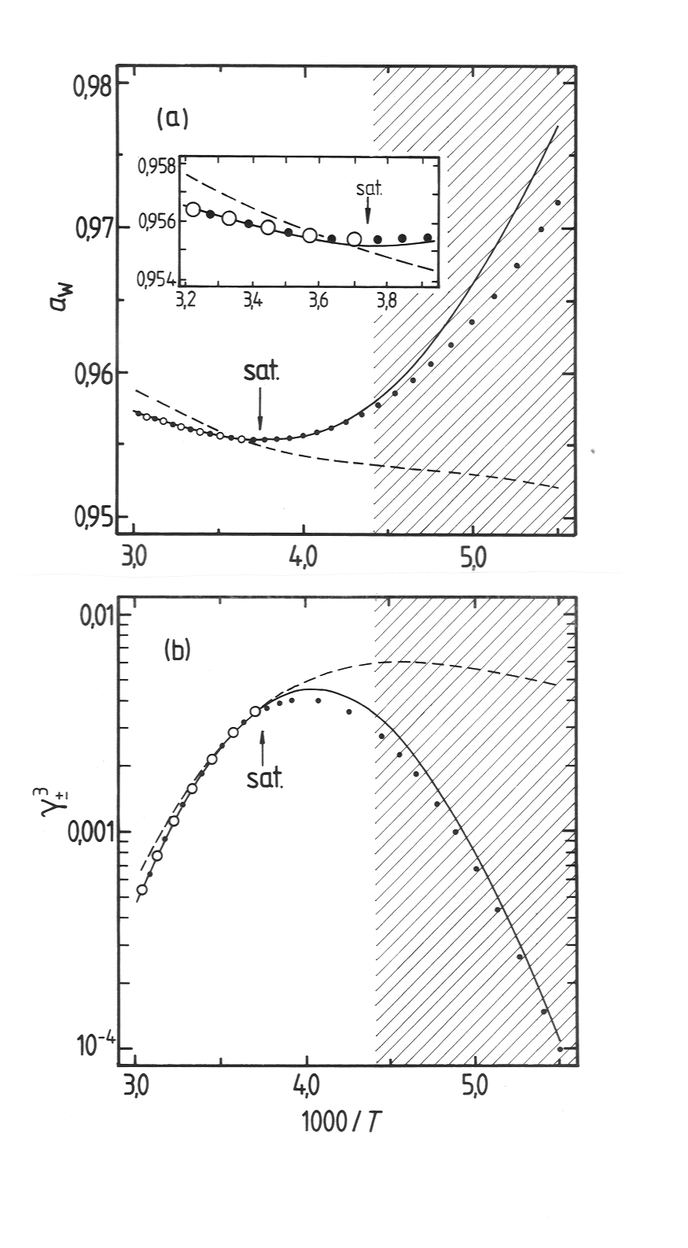
Fig. 1. Thermodynamic properties of 10 mass% (1.133 mol kg⁻¹) aqueous H₂SO₄ as a function 1/T, where T (K) is temperature. (a) Water activity (a_{w}), inset gives detail at high temperture. (b) Cube of the stoichiometric mean activity coefficient of H₂SO₄ (γ₊³). Symbols: open circles - critical review of Clegg et al.¹⁰; dots - Giauque et al.¹². Lines: solid - AIM model⁴; dashed - model of Knopf et al.¹

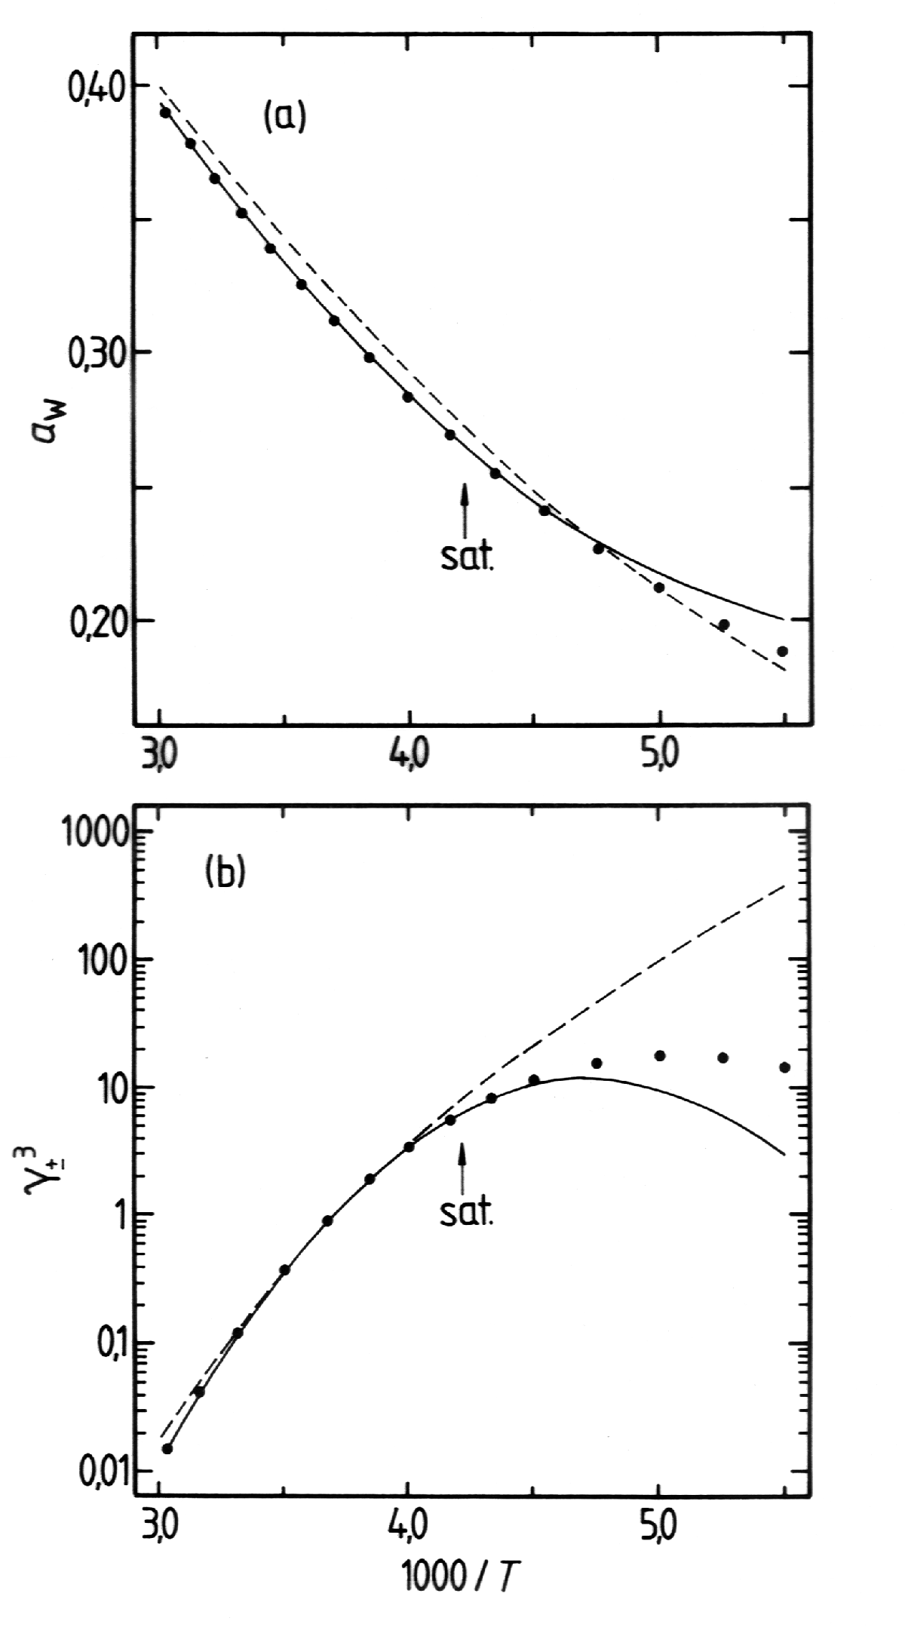
Fig. 2. Thermodynamic properties of 50 mass% (10.196 mol kg⁻¹) aqueous H₂SO₄ as a function 1/T, where T (K) is temperature. (a) Water activity (a_{w}). (b) Cube of the stoichiometric mean activity coefficient of H₂SO₄ (γ₊³). Symbols: - Giauque et al.¹². Lines: solid - model of Clegg and Brimblecombe⁴; dashed - model of Knopf et al.¹

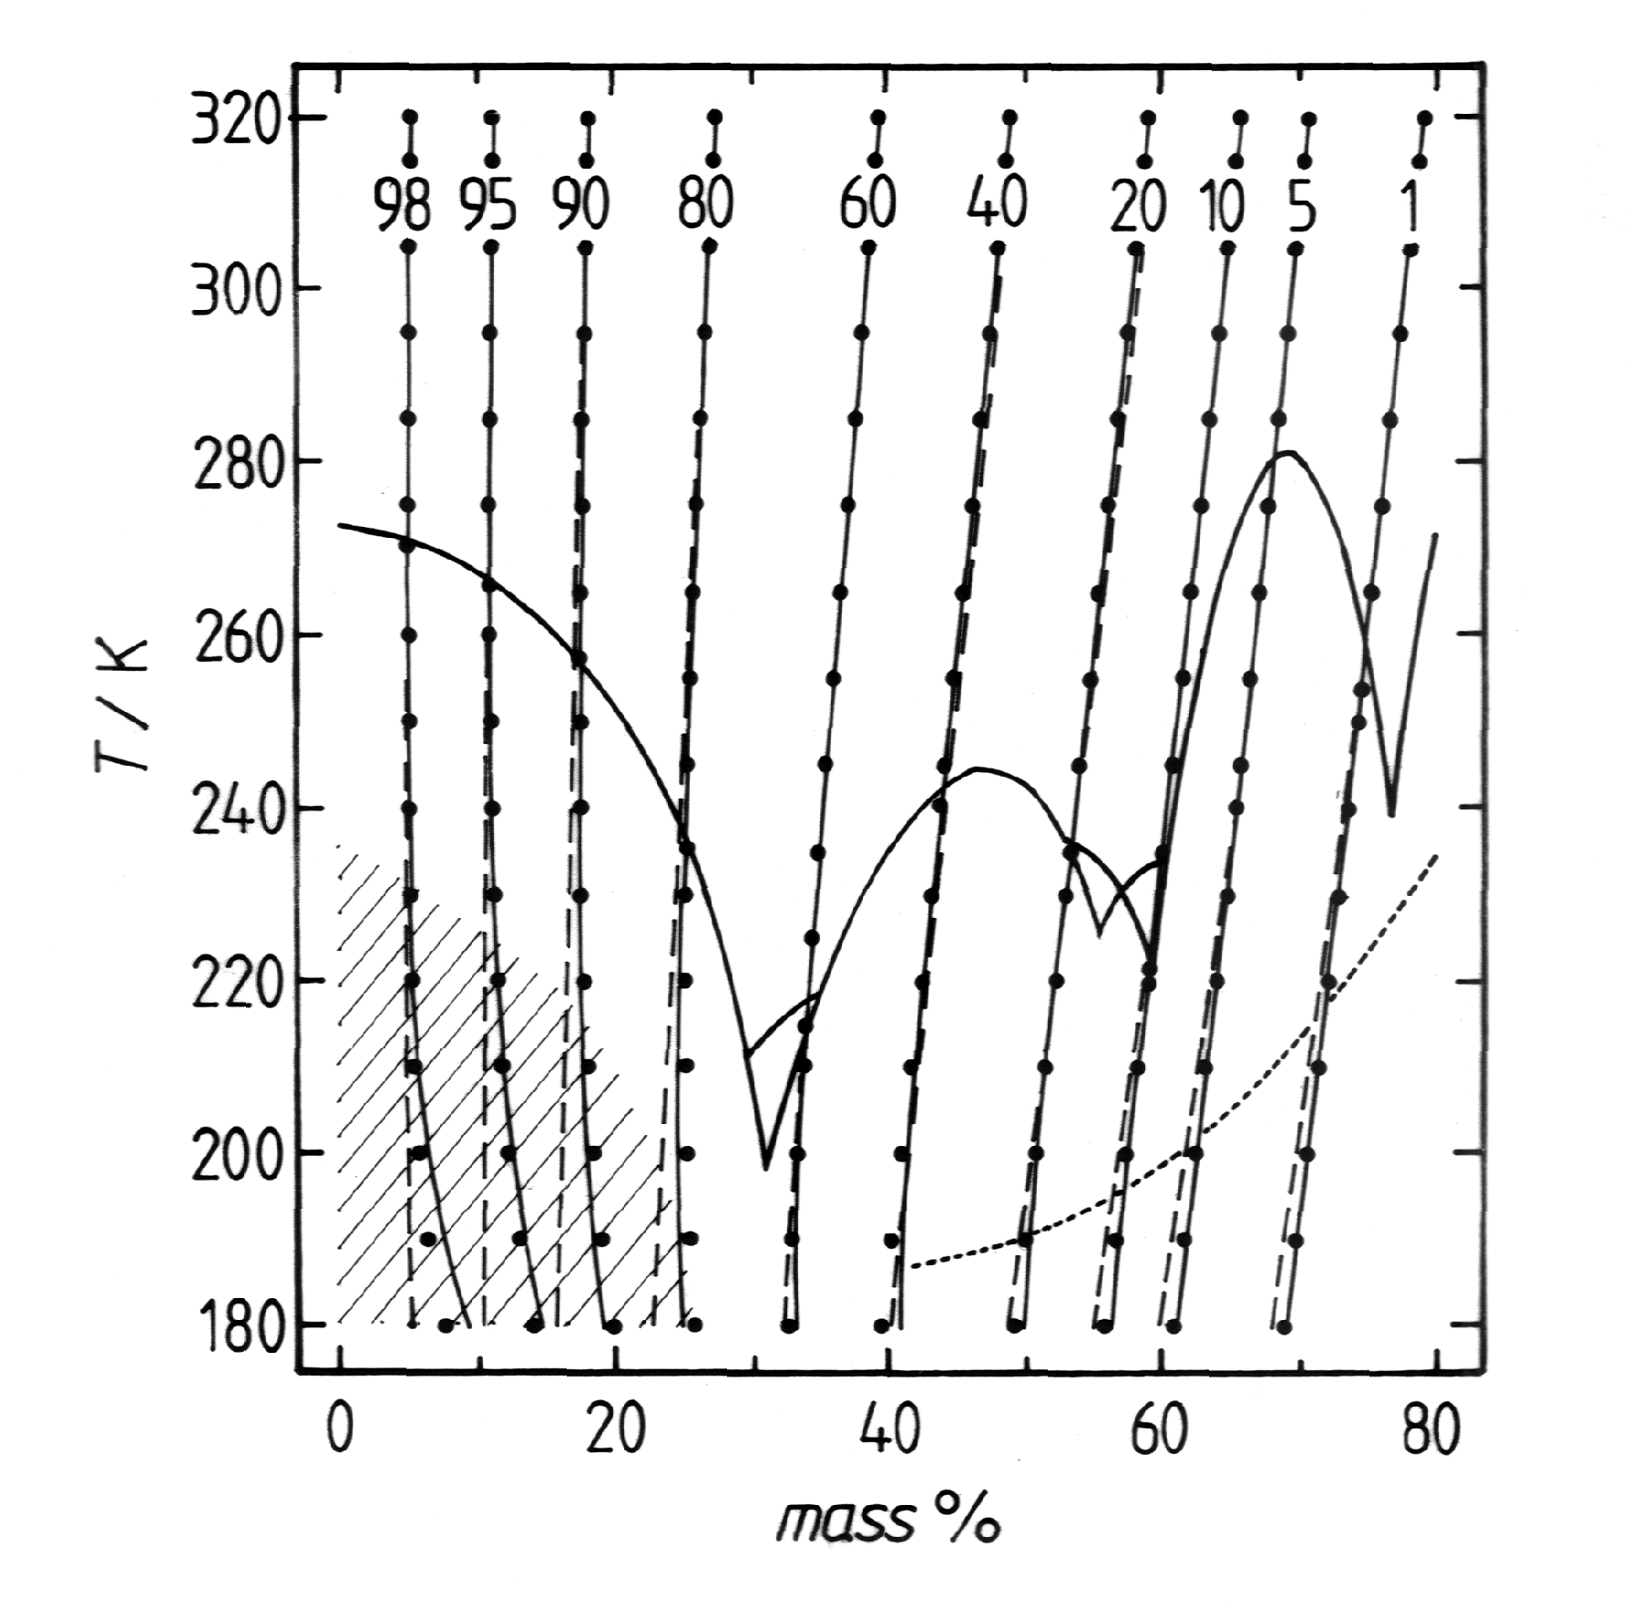
Fig. 3. Equilibrium relative humidities, from 1% to 98%, above aqueous H₂SO₄ as a function of temperature and mass% H₂SO₄. Symbols: calculated from the thermodynamic evaluation of Giauque et al.¹² Lines: solid - AIM model;⁴ dashed - model of Knopf et al;¹ thick solid - saturation of aqueous H₂SO₄ with respect to ice (furthest left) and H₂SO₄ hydrates; dotted - trajectory of a typical stratospheric H₂SO₄ droplet for 5ppmv H₂O and 100 mbar altitude. Hatched area: the upper boundary marks the practical limit of supercooling of dilute aqueous solutions before ice nucleation occurs.¹⁶

